# Dialogflow v2 json API

<https://dialogflowconnect.herokuapp.com/connectDialogflow/>

Currently handles fulfillment texts with context management and text-based intent detection. Future steps:

1. Enable custom payload,

2. Enable voice based intent detection

## How to add in my ChatFuel bot?

Add as GET request in ChatFuel

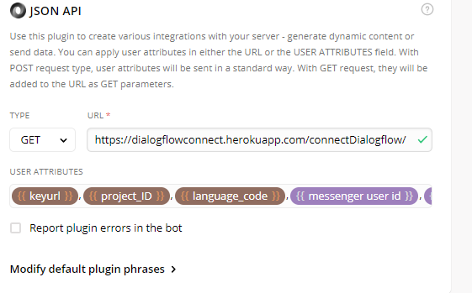

Things you would need as parameters (keep the same name as the API depends on these key values)

|  |  |
| --- | --- |
| {{keyurl}} | URL for your google credential service key, hosted on dropbox or similar service).  (note: this will be used and removed and will not be saved anywhere post request) If you are wondering how to generate it, I will be explaining that below |
| {{project_ID}} | go to your bot settings and select copy the project iD |
| {{language_code}} | In case your bot and dialogflow handles many languages you might want to take it from user programmatically using quick replies maybe, else enter the one that your bot handles in my case “en-US” |
| {{last user freeform input}} | Inbuilt in chatfuel |
| {{messenger user id}}: | Inbuilt (we will be using this value for session and context management) |

## But you still don’t how to create that keyurl, huh? Let’s do that.

We will be following steps from this url: <https://cloud.google.com/docs/authentication/getting-started>

Let start with create a service account, follow the link to open your Google cloud platform.

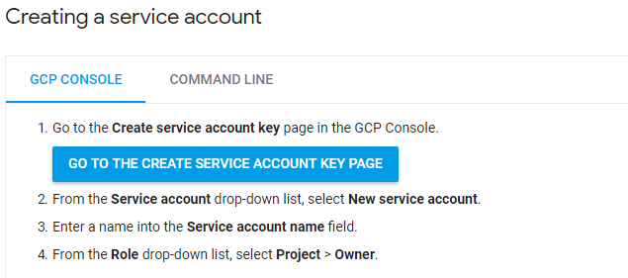

Select the project connected to your bot, if you are not able to find using name, check the ID, it should match with project ID in dialogflow.

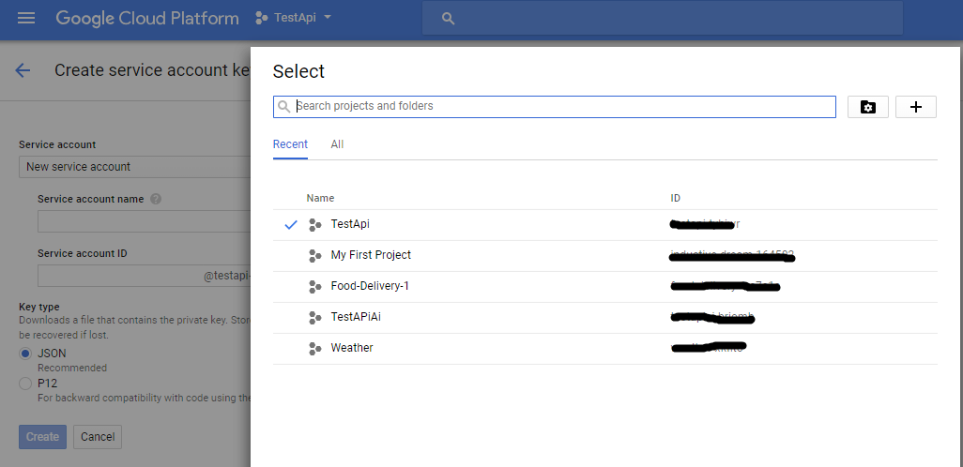

Select “New Service account”, provide any name you like and select role at project->owner

as mentioned in step 2,3 4 earlier.

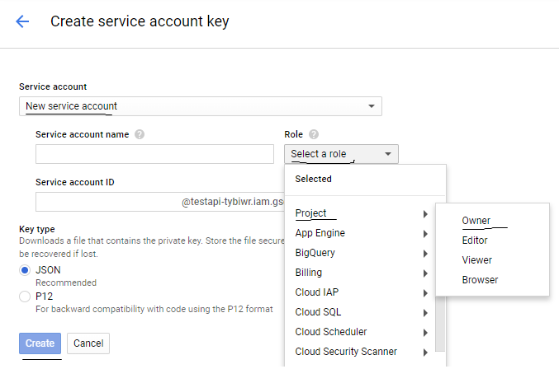

Download the json and upload it on dropbox, once upload click share and create a link for the file

You will get something like this:

[https://www.dropbox.com/s/yio1uc4srkn7jwq/<filename>.json?dl=0](https://www.dropbox.com/s/yio1uc4srkn7jwq/%3cfilename%3e.json?dl=0)

replace www with dl and remove anything after “.json”

new link

[https://dl.dropbox.com/s/yio1uc4srkn7jwq/<filename>.json](https://dl.dropbox.com/s/yio1uc4srkn7jwq/%3cfilename%3e.json)

and this my friend is you {{keyurl}}, NOTE: Not share this with anyone else apart from the people working on your team or project as they will have access. And as mentioned at my end this will not be stored and used once your request is complete.